Identifying Age-Related Conditions

Project Report

  - Course: CS 4662 - Advanced Machine Learning and Deep Learning
  - Instructor: Dr. Mohammad Pourhomayoun

  - Prepared by: Lcndr Aquino, Luis Chavez, Haonan Ma,
  - Joe Miranda, Huilin Zhang

Table of Contents
Project Overview: 3
Team Members and Roles: 3
Developed Methods, Algorithms, and Code Summary 4
1. Data Preparation and Preprocessing 4
2. Model Development (Traditional Machine Learning) 5
3. Advanced Models and Boosting (XGBoost) 6
4. Deep & Ensemble Learning 7
Results and Evaluation 8
5. Model Comparison and Performance 8
6. Visual Comparison of Models 9
7. ROC Curve and AUC Analysis 10
8. Class Imbalance and Recall Analysis 12
9. Feature Importance Analysis 12
10. Evaluation Summary 13
Conclusion 13
References 14

Project Overview:
This project focuses on predicting whether an individual has age-related medical conditions using anonymized biomedical features from the ICR dataset. The problem is formulated as a binary classification task, where the objective is not only to accurately classify individuals but also to generate well-calibrated probability estimates for each class.
The dataset consists of high-dimensional numerical features representing biological measurements, with a target variable indicating the presence or absence of specific medical conditions. One of the primary challenges in this problem is handling class imbalance and optimizing probabilistic predictions under the balanced log loss metric.
To address these challenges, we developed and evaluated a range of machine learning and deep learning models, including Logistic Regression, Support Vector Machines (SVM), Random Forest, gradient boosting methods (XGBoost and LightGBM), and multilayer perceptron (MLP) neural networks. Each model was implemented using a consistent preprocessing pipeline and evaluated using cross-validation to ensure robust and fair comparisons.
Model performance was evaluated using balanced log loss, ROC curves, and AUC scores to provide a comprehensive assessment of classification performance. By comparing these approaches, the project aims to identify the most effective modeling strategy for structured biomedical data and to analyze how different algorithms capture underlying patterns in the dataset.

Team Members and Roles:
Name | Role | Responsibilities
Joe Miranda | Project Manager | Coordinated project planning and timelines, managed the GitHub repository, integrated model outputs, and ensured consistency across all components of the project, including preparing the final report and slides.
Huilin Zhang | Data & Preprocessing | Performed data cleaning, handled missing values, applied feature scaling, and developed a consistent preprocessing pipeline used across all models.
Luis Chavez | Deep & Ensemble Learning | Designed and implemented neural network models, experimented with architectures and regularization techniques, and prepared model outputs for potential ensemble methods.
Haonan Ma | Boosting & Advanced Models | Developed and tuned gradient boosting models including XGBoost and LightGBM, performed hyperparameter optimization, and analyzed feature importance.
Lcndr Aquino | Traditional ML Models | Implemented baseline and traditional machine learning models including Logistic Regression, SVM, and Random Forest, and conducted performance comparisons using evaluation metrics.

Developed Methods, Algorithms, and Code Summary

Data Preparation and Preprocessing
The project began with loading the training and testing datasets, which consist of anonymized biomedical features along with a binary target variable indicating the presence of age-related medical conditions. An additional dataset, greeks.csv, was also incorporated to provide supplemental metadata available for the training set. This dataset includes categorical indicators of condition type and additional experimental attributes, which were merged with the training data using a common identifier.
Initial data inspection was performed to verify consistency between training and testing datasets. This included checking for mismatched columns and ensuring that both datasets shared the same feature structure. The target variable was present only in the training set, as expected for supervised learning tasks.
Data cleaning involved removing duplicate records and analyzing missing values across all features. Instead of discarding incomplete samples, missing values were handled using imputation to preserve the relatively small dataset size. Numerical features were imputed using the median of the training data, while categorical features were filled using the mode. To maintain consistency, imputation values derived from the training set were also applied to the test set.
Following imputation, the training and testing datasets were aligned to ensure identical feature columns. This step guaranteed that all models would operate on a consistent input space, preventing issues caused by mismatched features during training and evaluation.
After preprocessing, the cleaned datasets were saved for reuse in downstream modeling tasks. Additional exploratory data analysis was conducted to better understand the dataset, including visualization of class distribution, feature distributions, and correlations between variables. A class distribution analysis revealed the presence of imbalance in the target variable, reinforcing the need for appropriate evaluation metrics such as balanced log loss.

Model Development (Traditional Machine Learning)
To establish strong baseline performance and provide a foundation for comparison with more advanced models, several traditional machine learning algorithms were implemented, including Logistic Regression, Support Vector Machines (SVM), and Random Forest.
A unified preprocessing pipeline was constructed using a combination of imputation, scaling, and encoding techniques. Numerical features were imputed using the median and standardized using StandardScaler, while categorical features were imputed using the most frequent value and encoded using one-hot encoding. This preprocessing pipeline was integrated with each model using a Pipeline and ColumnTransformer, ensuring consistent data transformation across all experiments.
To address class imbalance in the dataset, all models were trained using class weighting strategies, which assign higher importance to underrepresented classes during training. Model evaluation was performed using stratified 5-fold cross-validation to preserve class distribution across splits and ensure robust performance estimates.
A custom evaluation metric, balanced log loss, was implemented to better reflect model performance under class imbalance. Additional evaluation metrics, including recall and F1 score for Class 1, were also used to better assess model performance under class imbalance. This metric computes the average log loss separately for each class and then averages the results, preventing dominance by the majority class. In addition to balanced log loss, standard metrics such as accuracy and log loss were also computed, along with classification reports and confusion matrices.
Logistic Regression was used as a baseline model due to its simplicity and interpretability. Both baseline and tuned versions were evaluated, with hyperparameters such as regularization strength and penalty type optimized using grid search. Support Vector Machines were implemented with both linear and radial basis function (RBF) kernels to capture both linear and nonlinear decision boundaries. Hyperparameters such as the regularization parameter (C) and kernel-specific parameters (e.g., gamma for RBF) were tuned using cross-validation.
Random Forest was included as an ensemble-based traditional model capable of capturing nonlinear relationships and feature interactions. Hyperparameters such as the number of trees, maximum depth, and minimum samples per split were tuned using grid search to balance model complexity and generalization.
Model performance was compared using cross-validated predictions, and the best-performing model was selected based on the lowest balanced log loss. This model was then retrained on the full dataset to produce final predictions and serve as a benchmark for comparison with boosting and deep learning approaches.

Advanced Models and Boosting (XGBoost)
To improve predictive performance beyond traditional machine learning methods, gradient boosting techniques were explored using XGBoost. Boosting methods are particularly well-suited for structured tabular data, as they iteratively build ensembles of decision trees that correct the errors of previous models.
The XGBoost model was trained using the cleaned dataset, with non-informative and categorical metadata features removed, including identifiers and auxiliary columns such as Id, EJ, and attributes from the supplemental dataset. This allowed the model to focus on numerical biomedical features most relevant to prediction.
An initial baseline model was trained using an 80/20 train-validation split with a fixed random state to ensure reproducibility. The baseline model achieved strong overall performance, with an accuracy of approximately 91%. However, further evaluation revealed that the model struggled to correctly identify the minority class (Class 1), with relatively low recall. This highlighted the impact of class imbalance on model performance.
To address this issue, class imbalance handling was incorporated using the scale_pos_weight parameter in XGBoost. This adjustment assigns greater importance to the minority class during training, improving the model’s ability to detect positive cases. After applying this weighting strategy, model performance improved significantly. Recall for Class 1 increased from approximately 0.59 to 0.73, while overall accuracy improved to approximately 92.7%. Additionally, log loss decreased from 0.216 to 0.203, indicating improved probability estimation.
Hyperparameter tuning was also explored by adjusting parameters such as the number of estimators, tree depth, and learning rate. These experiments demonstrated that deeper trees and lower learning rates can improve performance, though careful tuning is required to avoid overfitting.
To further analyze model behavior, feature importance was extracted from the trained XGBoost model. The results showed that a small subset of features dominated the prediction process. In particular, features such as DU, GH, AB, AZ, and CR were identified as the most influential. The importance scores declined rapidly beyond the top features, indicating that the model relies heavily on a limited number of variables. This insight provides valuable interpretability and suggests potential opportunities for feature selection and dimensionality reduction.
Overall, the boosting approach significantly outperformed traditional models in both predictive accuracy and the ability to handle class imbalance, making it one of the strongest candidates for the final model.

Deep & Ensemble Learning
To extend the project beyond traditional machine learning and boosting models, deep learning and ensemble methods were also implemented. The deep learning portion focused on multilayer perceptron neural networks using TensorFlow and Keras, while the ensemble portion explored stacking and blending strategies.
The cleaned training dataset was loaded from the preprocessing step, and non modeling columns such as Id, Class, EJ, Alpha, Beta, Gamma, Delta, and Epsilon were removed. The remaining numerical features were standardized using StandardScaler, which is important for neural networks because gradient based optimization is sensitive to feature scale. The data was split into training and validation sets using stratification to preserve the class distribution.
A baseline multilayer perceptron was first created using two hidden layers with ReLU activation and a sigmoid output layer for binary classification. The model used binary cross entropy loss and the Adam optimizer. Because the dataset is imbalanced, class weights were applied during training to place greater emphasis on the minority class. Early stopping was also used to reduce overfitting and restore the best validation weights.
Several architecture experiments were performed by varying the number of hidden layers and the number of neurons per layer. Additional regularization techniques were tested, including dropout, batch normalization, and L2 weight decay. The final neural network combined these methods using dense layers with 128 and 64 units, L2 regularization, batch normalization, dropout, and early stopping. This design was intended to improve generalization on a relatively small biomedical dataset.
In addition to neural networks, two ensemble strategies were implemented: stacking and blending. The stacking model combined Logistic Regression, Random Forest, Gradient Boosting, and XGBoost as base learners, with Logistic Regression used as the final meta learner. The stacking classifier used 5 fold cross validation internally to train the meta learner on out of fold predictions.
The blending model used a separate holdout strategy. Base models were trained on a portion of the training data, then their probability predictions on a holdout set were used as meta features. The blending approach included Logistic Regression, Random Forest, Gradient Boosting, XGBoost, and the best neural network as base models. A Logistic Regression meta learner was then trained to combine these predictions.
Overall, this section tested whether combining multiple learning approaches could improve predictive performance beyond individual models. The final comparison included the weighted XGBoost baseline, baseline neural network, regularized neural network, stacking ensemble, and blending ensemble. These models were evaluated alongside boosting and traditional methods to determine whether deep learning provides performance advantages for structured tabular data.

Results and Evaluation

Model Comparison and Performance
To evaluate the effectiveness of different approaches, we compared traditional machine learning models, boosting methods, deep learning models, and ensemble techniques using consistent evaluation metrics. These metrics included accuracy, recall for Class 1, F1 score, and log loss.
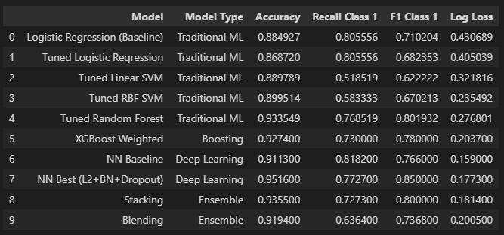

Visual Comparison of Models
To better illustrate model performance, we generated bar charts comparing accuracy, recall for Class 1, and log loss across all models.
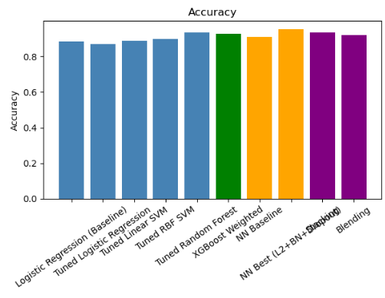
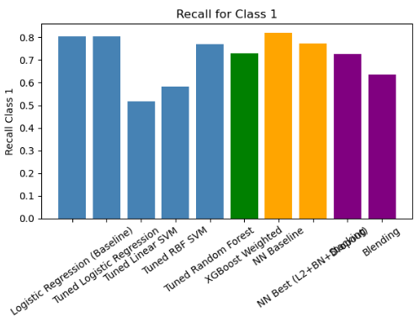
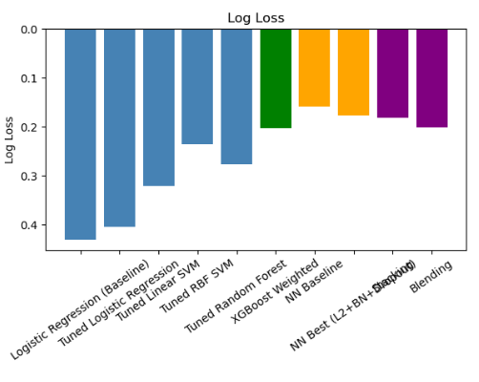
The visualization highlights clear performance differences across model types. Deep learning models achieved the highest accuracy, while boosting and ensemble methods provided balanced performance across metrics. Traditional models, although slightly less accurate, still served as strong baselines.

ROC Curve and AUC Analysis
ROC curves were used to evaluate how well each model distinguishes between Class 0 and Class 1 across different classification thresholds. Unlike accuracy, ROC/AUC provides a threshold independent measure of classification performance, making it useful for comparing models on an imbalanced dataset.
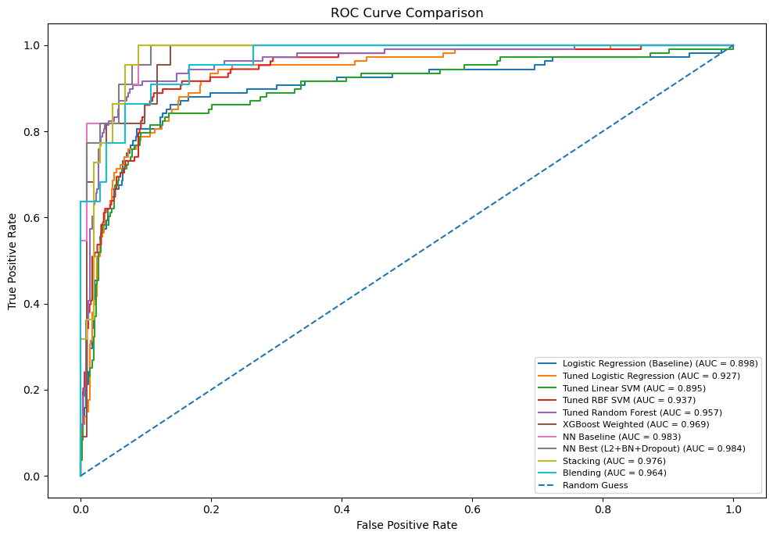
The AUC scores provide an additional comparison of model discrimination ability. Models with higher AUC values are better at separating individuals with age-related conditions from those without conditions.
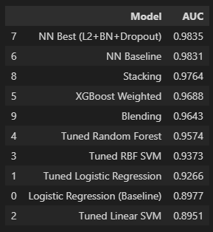
Overall, the ROC/AUC results support the broader model comparison by showing which models provide the strongest separation between classes. These results are especially important because the dataset is imbalanced and accuracy alone may not fully represent model quality.

Class Imbalance and Recall Analysis
A key challenge in this project was class imbalance, where the number of samples in Class 0 exceeded those in Class 1. This imbalance significantly affected model performance, particularly in recall for Class 1.
The results show that some models, such as Logistic Regression, achieved relatively high recall but suffered from poor log loss, indicating less reliable probability estimates. In contrast, models such as XGBoost and neural networks achieved a better balance between recall and overall performance.
Notably, the XGBoost model showed significant improvement in recall after applying class weighting, increasing from approximately 0.59 to 0.73. This demonstrates the importance of explicitly handling class imbalance when working with real-world datasets.
In this context, recall for Class 1 is especially important, as it represents correctly identifying individuals with age-related conditions. Therefore, models with higher recall are more valuable, even if they do not achieve the highest overall accuracy.

Feature Importance Analysis
A feature importance analysis was conducted using the XGBoost model to better understand the factors driving predictions.
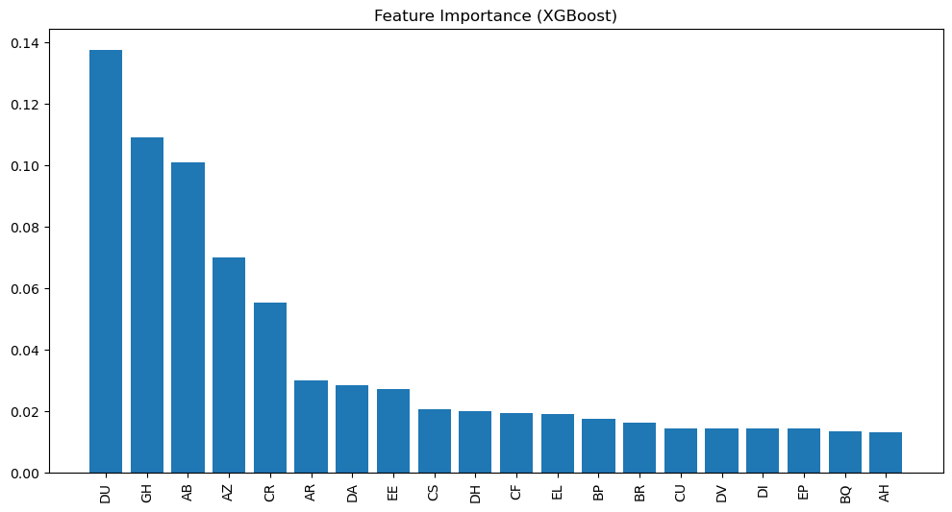
The results show that a small subset of features, including DU, GH, AB, AZ, and CR, contributed most significantly to model predictions. The importance scores declined rapidly beyond these top features, indicating that the model relies heavily on a limited number of variables.
This finding suggests that many features have minimal impact on performance and that future improvements could include feature selection or dimensionality reduction techniques.

Evaluation Summary
Overall, the results demonstrate that advanced methods, particularly deep learning and boosting models, outperform traditional machine learning approaches on this task. Neural networks achieved the highest accuracy and best probability calibration, while XGBoost provided strong and consistent performance with improved handling of class imbalance.
Ensemble methods, including stacking and blending, did not significantly outperform the best individual models. This suggests that the base models may have learned similar patterns, limiting the benefits of combining them.
These findings highlight the importance of selecting appropriate evaluation metrics and balancing multiple performance objectives. In particular, optimizing recall for Class 1 and minimizing log loss proved to be more meaningful than maximizing accuracy alone.

Conclusion
This project explored a range of machine learning approaches for predicting age-related medical conditions using structured biomedical data. Models from four categories were evaluated, including traditional machine learning methods, boosting techniques, deep learning models, and ensemble strategies.
The results demonstrate that no single model was optimal across all evaluation metrics. The regularized neural network achieved the highest overall accuracy and strongest F1 score, while the baseline neural network produced the lowest log loss, indicating superior probability calibration. XGBoost remained a strong and reliable model, particularly after incorporating class imbalance handling, and provided valuable interpretability through feature importance analysis.
Traditional machine learning models, especially Random Forest, performed competitively and served as effective baselines. However, simpler models such as Logistic Regression and Support Vector Machines showed limitations in handling class imbalance and maintaining consistent performance across metrics.
Ensemble methods, including stacking and blending, did not significantly outperform the best individual models. This suggests that the base models captured similar patterns in the data, limiting the additional benefit of combining them.
A key finding of this project is that evaluation metrics must be carefully selected based on the problem context. In this case, recall for Class 1 and log loss were more meaningful than accuracy alone, as they better reflect the ability to identify individuals with medical conditions and produce reliable probability estimates.
Overall, the results highlight the effectiveness of boosting and deep learning methods for structured tabular data, while also emphasizing the importance of handling class imbalance and evaluating models using multiple performance metrics.

References
Kaggle: https://www.kaggle.com/competitions/icr-identify-age-related-conditions
Git repository: https://github.com/jmiralo84/CS4662-Project-Identifying-Age-Related-Conditions

